Міністерство освіти і науки України
Національний технічний університет України
«Київський політехнічний інститут імені Ігоря Сікорського»
Факультет інформатики та обчислювальної техніки
Кафедра обчислювальної техніки

Лабораторна робота №5
з дисципліни
«Об’єктно-орієнтоване програмування»
на тему
Розробка багатовіконного інтерфейсу користувача
для графічного редактора об’єктів

Виконав: Перевірив:
студент групи ІМ-55 Рекечинський Д. О.
Останін Олександр Сергійович
Номер в списку - 21

Київ 2026
Завдання
Завдання
1. Створити у середовищі розробки проект з ім’ям Lab5.
2. Написати вихідний текст програми згідно варіанту завдання.
3. Скомпілювати вихідний текст і отримати виконуваний файл програми.
4. Перевірити роботу програми. За потреби налагодити програму.
5. Проаналізувати та прокоментувати результати та вихідний текст
програми.
6. Оформити звіт.

Код програми

Lab5.cpp
// Lab5.cpp : Defines the entry point for the application.
//

#include "framework.h"
#include "Lab5.h"
#include "MyEditor.h"
#include <windowsx.h>

#define MAX_LOADSTRING 100

// Global Variables:
HINSTANCE hInst; // current instance
WCHAR szTitle[MAX_LOADSTRING]; // The title bar text
WCHAR szWindowClass[MAX_LOADSTRING]; // the main window class name

// Forward declarations of functions included in this code module:
ATOM MyRegisterClass(HINSTANCE hInstance);
BOOL InitInstance(HINSTANCE, int);
LRESULT CALLBACK WndProc(HWND, UINT, WPARAM, LPARAM);
INT_PTR CALLBACK About(HWND, UINT, WPARAM, LPARAM);

int APIENTRY wWinMain(_In_ HINSTANCE hInstance,
_In_opt_ HINSTANCE hPrevInstance,
_In_ LPWSTR lpCmdLine,
_In_ int nCmdShow)
{
UNREFERENCED_PARAMETER(hPrevInstance);
UNREFERENCED_PARAMETER(lpCmdLine);

// TODO: Place code here.

// Initialize global strings
LoadStringW(hInstance, IDS_APP_TITLE, szTitle, MAX_LOADSTRING);
LoadStringW(hInstance, IDC_LAB5, szWindowClass, MAX_LOADSTRING);
MyRegisterClass(hInstance);

// Perform application initialization:
if (!InitInstance(hInstance, nCmdShow))
{
return FALSE;
}

HACCEL hAccelTable = LoadAccelerators(hInstance, MAKEINTRESOURCE(IDC_LAB5));

MSG msg;

// Main message loop:
while (GetMessage(&msg, nullptr, 0, 0))
{
HWND hTable = MyEditor::Instance().TableWindow();
if (hTable && IsDialogMessage(hTable, &msg))
continue;

if (!TranslateAccelerator(msg.hwnd, hAccelTable, &msg))
{
TranslateMessage(&msg);
DispatchMessage(&msg);
}
}

return (int)msg.wParam;
}

//
// FUNCTION: MyRegisterClass()
//
// PURPOSE: Registers the window class.
//
ATOM MyRegisterClass(HINSTANCE hInstance)
{
WNDCLASSEXW wcex;

wcex.cbSize = sizeof(WNDCLASSEX);

wcex.style = CS_HREDRAW | CS_VREDRAW;
wcex.lpfnWndProc = WndProc;
wcex.cbClsExtra = 0;
wcex.cbWndExtra = 0;
wcex.hInstance = hInstance;
wcex.hIcon = LoadIcon(hInstance, MAKEINTRESOURCE(IDI_LAB5));
wcex.hCursor = LoadCursor(nullptr, IDC_ARROW);
wcex.hbrBackground = (HBRUSH)(COLOR_WINDOW + 1);
wcex.lpszMenuName = MAKEINTRESOURCEW(IDC_LAB5);
wcex.lpszClassName = szWindowClass;
wcex.hIconSm = LoadIcon(wcex.hInstance, MAKEINTRESOURCE(IDI_SMALL));

return RegisterClassExW(&wcex);
}

//
// FUNCTION: InitInstance(HINSTANCE, int)
//
// PURPOSE: Saves instance handle and creates main window
//
// COMMENTS:
//
// In this function, we save the instance handle in a global variable and
// create and display the main program window.
//
BOOL InitInstance(HINSTANCE hInstance, int nCmdShow)
{
hInst = hInstance; // Store instance handle in our global variable

HWND hWnd = CreateWindowW(szWindowClass, szTitle, WS_OVERLAPPEDWINDOW | WS_CLIPCHILDREN,
CW_USEDEFAULT, 0, CW_USEDEFAULT, 0, nullptr, nullptr, hInstance, nullptr);

if (!hWnd)
{
return FALSE;
}

ShowWindow(hWnd, nCmdShow);
UpdateWindow(hWnd);

return TRUE;
}

//
// FUNCTION: WndProc(HWND, UINT, WPARAM, LPARAM)
//
// PURPOSE: Processes messages for the main window.
//
// WM_COMMAND - process the application menu
// WM_PAINT - Paint the main window
// WM_DESTROY - post a quit message and return
//
//
LRESULT CALLBACK WndProc(HWND hWnd, UINT message, WPARAM wParam, LPARAM lParam)
{
switch (message)
{
case WM_CREATE:
MyEditor::Instance().OnCreate(hWnd, hInst);
break;
case WM_SIZE:
MyEditor::Instance().OnSize();
break;
case WM_COMMAND:
{
int wmId = LOWORD(wParam);
if (MyEditor::Instance().OnCommand(wmId))
break;
switch (wmId)
{
case IDM_ABOUT:
DialogBox(hInst, MAKEINTRESOURCE(IDD_ABOUTBOX), hWnd, About);
break;
case IDM_EXIT:
DestroyWindow(hWnd);
break;
default:
return DefWindowProc(hWnd, message, wParam, lParam);
}
}
break;
case WM_INITMENUPOPUP:
MyEditor::Instance().OnInitMenuPopup((HMENU)wParam);
break;
case WM_NOTIFY:
return MyEditor::Instance().OnNotify(lParam);
case WM_LBUTTONDOWN:
MyEditor::Instance().OnLButtonDown(GET_X_LPARAM(lParam), GET_Y_LPARAM(lParam));
break;
case WM_MOUSEMOVE:
MyEditor::Instance().OnMouseMove(GET_X_LPARAM(lParam), GET_Y_LPARAM(lParam));
break;
case WM_LBUTTONUP:
MyEditor::Instance().OnLButtonUp(GET_X_LPARAM(lParam), GET_Y_LPARAM(lParam));
break;
case WM_PAINT:
{
// TODO: Add any drawing code here...
MyEditor::Instance().OnPaint();
}
break;
case WM_DESTROY:
MyEditor::Instance().OnDestroy();
PostQuitMessage(0);
break;
default:
return DefWindowProc(hWnd, message, wParam, lParam);
}
return 0;
}

// Message handler for about box.
INT_PTR CALLBACK About(HWND hDlg, UINT message, WPARAM wParam, LPARAM lParam)
{
UNREFERENCED_PARAMETER(lParam);
switch (message)
{
case WM_INITDIALOG:
return (INT_PTR)TRUE;

case WM_COMMAND:
if (LOWORD(wParam) == IDOK || LOWORD(wParam) == IDCANCEL)
{
EndDialog(hDlg, LOWORD(wParam));
return (INT_PTR)TRUE;
}
break;
}
return (INT_PTR)FALSE;
}

Shapes.h

#pragma once
#include <windows.h>

class Shape
{
protected:
long xs1 = 0, ys1 = 0, xs2 = 0, ys2 = 0;

static HPEN MakePen(bool trace, COLORREF color, int width = 1)
{
if (trace) return CreatePen(PS_DOT, 1, RGB(0, 0, 0));
return CreatePen(PS_SOLID, width, color);
}

public:
virtual ~Shape() {}
void Set(long x1, long y1, long x2, long y2) { xs1 = x1; ys1 = y1; xs2 = x2; ys2 = y2; }

virtual void Show(HDC hdc, bool trace) = 0;
virtual Shape* Clone() const = 0;
virtual const wchar_t* Name() const = 0;

long X1() const { return xs1; }
long Y1() const { return ys1; }
long X2() const { return xs2; }
long Y2() const { return ys2; }
};

class PointShape : public Shape
{
public:
void Show(HDC hdc, bool trace) override
{
HPEN hPen = MakePen(trace, RGB(0, 0, 0), 4);
HPEN hOld = (HPEN)SelectObject(hdc, hPen);
MoveToEx(hdc, xs1, ys1, nullptr);
LineTo(hdc, xs1 + 1, ys1);
SelectObject(hdc, hOld);
DeleteObject(hPen);
}
Shape* Clone() const override { return new PointShape(*this); }
const wchar_t* Name() const override { return L"Dot"; }
};

class LineShape : public virtual Shape
{
public:
void Show(HDC hdc, bool trace) override
{
HPEN hPen = MakePen(trace, RGB(0, 0, 0));
HPEN hOld = (HPEN)SelectObject(hdc, hPen);
MoveToEx(hdc, xs1, ys1, nullptr);
LineTo(hdc, xs2, ys2);
SelectObject(hdc, hOld);
DeleteObject(hPen);
}
Shape* Clone() const override { return new LineShape(*this); }
const wchar_t* Name() const override { return L"Line"; }
};

class RectShape : public virtual Shape
{
protected:
bool m_fill = true;
public:
void Show(HDC hdc, bool trace) override
{
bool fill = m_fill && !trace;
HPEN hPen = MakePen(trace, RGB(0, 0, 0));
HBRUSH hBrush = fill ? CreateSolidBrush(RGB(255, 165, 0))
: (HBRUSH)GetStockObject(NULL_BRUSH);
HPEN hOldPen = (HPEN)SelectObject(hdc, hPen);
HBRUSH hOldBrush = (HBRUSH)SelectObject(hdc, hBrush);

Rectangle(hdc, min(xs1, xs2), min(ys1, ys2), max(xs1, xs2), max(ys1, ys2));

SelectObject(hdc, hOldPen);
SelectObject(hdc, hOldBrush);
DeleteObject(hPen);
if (fill) DeleteObject(hBrush);
}
Shape* Clone() const override { return new RectShape(*this); }
const wchar_t* Name() const override { return L"Rectangle"; }
};

class EllipseShape : public virtual Shape
{
public:
void Show(HDC hdc, bool trace) override
{
long ox = 2 * xs1 - xs2;
long oy = 2 * ys1 - ys2;

HPEN hPen = MakePen(trace, RGB(0, 0, 0));
HPEN hOldPen = (HPEN)SelectObject(hdc, hPen);
HBRUSH hOldBrush = (HBRUSH)SelectObject(hdc, GetStockObject(NULL_BRUSH));

Ellipse(hdc, min(xs2, ox), min(ys2, oy), max(xs2, ox), max(ys2, oy));

SelectObject(hdc, hOldPen);
SelectObject(hdc, hOldBrush);
DeleteObject(hPen);
}
Shape* Clone() const override { return new EllipseShape(*this); }
const wchar_t* Name() const override { return L"Ellipse"; }
};

class LineOOShape : public LineShape, public EllipseShape
{
public:
void Show(HDC hdc, bool trace) override
{
long x1 = xs1, y1 = ys1, x2 = xs2, y2 = ys2;
const long r = 6;

LineShape::Show(hdc, trace);

Set(x1, y1, x1 + r, y1 + r);
EllipseShape::Show(hdc, trace);
Set(x2, y2, x2 + r, y2 + r);
EllipseShape::Show(hdc, trace);

Set(x1, y1, x2, y2);
}
Shape* Clone() const override { return new LineOOShape(*this); }
const wchar_t* Name() const override { return L"Line with circles"; }
};

class CubeShape : public RectShape, public LineShape
{
public:
CubeShape() { m_fill = false; }
void Show(HDC hdc, bool trace) override
{
long x1 = xs1, y1 = ys1, x2 = xs2, y2 = ys2;
long w = x2 > x1 ? x2 - x1 : x1 - x2;
long h = y2 > y1 ? y2 - y1 : y1 - y2;
long d = (w < h ? w : h) / 3;

Set(x1 + d, y1 - d, x2 + d, y2 - d);
RectShape::Show(hdc, trace);

Set(x1, y1, x1 + d, y1 - d); LineShape::Show(hdc, trace);
Set(x2, y1, x2 + d, y1 - d); LineShape::Show(hdc, trace);
Set(x1, y2, x1 + d, y2 - d); LineShape::Show(hdc, trace);
Set(x2, y2, x2 + d, y2 - d); LineShape::Show(hdc, trace);

Set(x1, y1, x2, y2);
RectShape::Show(hdc, trace);
}
Shape* Clone() const override { return new CubeShape(*this); }
const wchar_t* Name() const override { return L"Cube"; }
};

MyEditor.cpp

#include "framework.h"
#include "Resource.h"
#include "MyEditor.h"
#include <commdlg.h>
#include <cstdio>
#include <cwchar>

#pragma comment(lib, "comctl32.lib")
#pragma comment(lib, "comdlg32.lib")

MyEditor& MyEditor::Instance()
{
static MyEditor instance;
return instance;
}

MyEditor::MyEditor()
: m_hWnd(nullptr), m_hToolbar(nullptr), m_hImageList(nullptr),
m_cur(2), m_nCount(0), m_bTracking(false),
m_ptStart{}, m_ptCurrent{}
{
m_tools[0] = { ID_OBJECTS_DOT, new PointShape };
m_tools[1] = { ID_OBJECTS_LINE, new LineShape };
m_tools[2] = { ID_OBJECTS_RECTANGLE, new RectShape };
m_tools[3] = { ID_OBJECTS_ELLIPSE, new EllipseShape };
m_tools[4] = { ID_OBJECTS_LINEOO, new LineOOShape };
m_tools[5] = { ID_OBJECTS_CUBE, new CubeShape };

for (int i = 0; i < N; ++i)
m_pShapes[i] = nullptr;
}

MyEditor::~MyEditor()
{
for (int i = 0; i < TOOLS; ++i)
delete m_tools[i].proto;
}

void MyEditor::OnCreate(HWND hWnd, HINSTANCE hInst)
{
m_hWnd = hWnd;
CreateToolbar(hInst);
Select(m_cur);
m_table.Create(hInst, hWnd, IDD_TABLE);
}

void MyEditor::CreateToolbar(HINSTANCE hInst)
{
INITCOMMONCONTROLSEX icex = { sizeof(icex), ICC_BAR_CLASSES };
InitCommonControlsEx(&icex);

m_hToolbar = CreateWindowEx(0, TOOLBARCLASSNAME, nullptr,
WS_CHILD | WS_VISIBLE | TBSTYLE_FLAT | TBSTYLE_TOOLTIPS,
0, 0, 0, 0, m_hWnd, nullptr, hInst, nullptr);
SendMessage(m_hToolbar, TB_BUTTONSTRUCTSIZE, sizeof(TBBUTTON), 0);

m_hImageList = ImageList_LoadImage(hInst, MAKEINTRESOURCE(IDB_TOOLBAR),
24, 0, RGB(255, 255, 255), IMAGE_BITMAP, LR_CREATEDIBSECTION);
SendMessage(m_hToolbar, TB_SETIMAGELIST, 0, (LPARAM)m_hImageList);

TBBUTTON buttons[TOOLS] = {};
for (int i = 0; i < TOOLS; ++i)
{
buttons[i].iBitmap = i;
buttons[i].idCommand = m_tools[i].cmd;
buttons[i].fsState = TBSTATE_ENABLED;
buttons[i].fsStyle = BTNS_CHECKGROUP;
}
SendMessage(m_hToolbar, TB_ADDBUTTONS, TOOLS, (LPARAM)buttons);
SendMessage(m_hToolbar, TB_AUTOSIZE, 0, 0);
}

void MyEditor::OnSize()
{
if (m_hToolbar)
SendMessage(m_hToolbar, TB_AUTOSIZE, 0, 0);
}

void MyEditor::Select(int index)
{
m_cur = index;
SendMessage(m_hToolbar, TB_CHECKBUTTON, m_tools[index].cmd, TRUE);
}

bool MyEditor::OnCommand(int id)
{
if (id == ID_VIEW_TABLE)
{
m_table.Show(!m_table.IsVisible());
return true;
}

if (id == ID_FILE_SAVE) { SaveToFile(); return true; }

if (id == ID_FILE_OPEN) { LoadFromFile(); return true; }

for (int i = 0; i < TOOLS; ++i)
if (m_tools[i].cmd == id)
{
Select(i);
return true;
}
return false;
}

void MyEditor::OnInitMenuPopup(HMENU hMenu)
{
for (int i = 0; i < TOOLS; ++i)
CheckMenuItem(hMenu, m_tools[i].cmd,
MF_BYCOMMAND | (i == m_cur ? MF_CHECKED : MF_UNCHECKED));

CheckMenuItem(hMenu, ID_VIEW_TABLE,
MF_BYCOMMAND | (m_table.IsVisible() ? MF_CHECKED : MF_UNCHECKED));
}

LRESULT MyEditor::OnNotify(LPARAM lParam)
{
LPNMHDR pHdr = (LPNMHDR)lParam;
if (pHdr->code == TTN_GETDISPINFO)
{
LPNMTTDISPINFO pInfo = (LPNMTTDISPINFO)lParam;
GetMenuString(GetMenu(m_hWnd), (UINT)pHdr->idFrom, pInfo->szText, 80, MF_BYCOMMAND);

WCHAR* src = pInfo->szText;
WCHAR* dst = pInfo->szText;
for (; *src; ++src)
if (*src != L'&') *dst++ = *src;
*dst = L'\0';

pInfo->lpszText = pInfo->szText;
}
return 0;
}

void MyEditor::DrawTrace(HDC hdc)
{
int oldROP = SetROP2(hdc, R2_NOTXORPEN);
Shape* p = m_tools[m_cur].proto;
p->Set(m_ptStart.x, m_ptStart.y, m_ptCurrent.x, m_ptCurrent.y);
p->Show(hdc, true);
SetROP2(hdc, oldROP);
}

void MyEditor::OnLButtonDown(int x, int y)
{
m_ptStart.x = m_ptCurrent.x = x;
m_ptStart.y = m_ptCurrent.y = y;
m_bTracking = true;
SetCapture(m_hWnd);
}

void MyEditor::OnMouseMove(int x, int y)
{
if (!m_bTracking) return;
HDC hdc = GetDC(m_hWnd);
DrawTrace(hdc);
m_ptCurrent.x = x;
m_ptCurrent.y = y;
DrawTrace(hdc);
ReleaseDC(m_hWnd, hdc);
}

void MyEditor::OnLButtonUp(int x, int y)
{
if (!m_bTracking) return;

HDC hdc = GetDC(m_hWnd);
DrawTrace(hdc);
ReleaseDC(m_hWnd, hdc);
m_bTracking = false;
ReleaseCapture();

if (m_nCount >= N) return;

Shape* p = m_tools[m_cur].proto->Clone();
p->Set(m_ptStart.x, m_ptStart.y, x, y);
m_pShapes[m_nCount++] = p;
UpdateTable();
InvalidateRect(m_hWnd, nullptr, TRUE);
}

void MyEditor::OnPaint()
{
PAINTSTRUCT ps;
HDC hdc = BeginPaint(m_hWnd, &ps);
for (int i = 0; i < m_nCount; ++i)
m_pShapes[i]->Show(hdc, false);
EndPaint(m_hWnd, &ps);
}

void MyEditor::OnDestroy()
{
m_table.Destroy();
for (int i = 0; i < m_nCount; ++i)
delete m_pShapes[i];
m_nCount = 0;
if (m_hImageList)
ImageList_Destroy(m_hImageList);
}

void MyEditor::UpdateTable()
{
m_table.Clear();
for (int i = 0; i < m_nCount; ++i)
{
Shape* p = m_pShapes[i];
m_table.AddRow(p->Name(), p->X1(), p->Y1(), p->X2(), p->Y2());
}
}

void MyEditor::SaveToFile()
{
WCHAR fileName[MAX_PATH] = L"shapes.csv";

OPENFILENAME ofn = {};
ofn.lStructSize = sizeof(ofn);
ofn.hwndOwner = m_hWnd;
ofn.lpstrFilter = L"CSV files (*.csv)\0*.csv\0All files (*.*)\0*.*\0";
ofn.lpstrFile = fileName;
ofn.nMaxFile = MAX_PATH;
ofn.lpstrDefExt = L"csv";
ofn.Flags = OFN_OVERWRITEPROMPT | OFN_PATHMUSTEXIST;

if (!GetSaveFileName(&ofn)) return;

FILE* f = nullptr;
if (_wfopen_s(&f, fileName, L"w") != 0 || !f)
{
MessageBox(m_hWnd, L"?? ??????? ???????? ????", L"???????", MB_ICONERROR);
return;
}

fwprintf(f, L"Name,x1,y1,x2,y2\n");
for (int i = 0; i < m_nCount; ++i)
{
Shape* p = m_pShapes[i];
fwprintf(f, L"%ls,%ld,%ld,%ld,%ld\n",
p->Name(), p->X1(), p->Y1(), p->X2(), p->Y2());
}
fclose(f);
}

void MyEditor::LoadFromFile()
{
WCHAR fileName[MAX_PATH] = L"";

OPENFILENAME ofn = {};
ofn.lStructSize = sizeof(ofn);
ofn.hwndOwner = m_hWnd;
ofn.lpstrFilter = L"CSV files (*.csv)\0*.csv\0All files (*.*)\0*.*\0";
ofn.lpstrFile = fileName;
ofn.nMaxFile = MAX_PATH;
ofn.Flags = OFN_FILEMUSTEXIST | OFN_PATHMUSTEXIST;

if (!GetOpenFileName(&ofn)) return;

FILE* f = nullptr;
if (_wfopen_s(&f, fileName, L"r") != 0 || !f)
{
MessageBox(m_hWnd, L"Не вдалося відкрити файл", L"Помилка", MB_ICONERROR);
return;
}

for (int i = 0; i < m_nCount; ++i)
delete m_pShapes[i];
m_nCount = 0;

WCHAR line[256], name[64];
long x1, y1, x2, y2;
while (fgetws(line, 256, f) && m_nCount < N)
{
// назва — усе до коми, далі 4 числа
if (swscanf_s(line, L"%63[^,],%ld,%ld,%ld,%ld",
name, (unsigned)_countof(name), &x1, &y1, &x2, &y2) != 5)
continue;

for (int t = 0; t < TOOLS; ++t)
if (wcscmp(m_tools[t].proto->Name(), name) == 0)
{
Shape* p = m_tools[t].proto->Clone();
p->Set(x1, y1, x2, y2);
m_pShapes[m_nCount++] = p;
break;
}
}
fclose(f);

UpdateTable();
InvalidateRect(m_hWnd, nullptr, TRUE);
}

MyEditor.h

#pragma once
#include <windows.h>
#include <commctrl.h>
#include "Shapes.h"
#include "MyTable.h"

class MyEditor
{
public:
static const int N = 122;
static const int TOOLS = 6;

static MyEditor& Instance();

MyEditor(const MyEditor&) = delete;
MyEditor& operator=(const MyEditor&) = delete;

void OnCreate(HWND hWnd, HINSTANCE hInst);
void OnSize();
bool OnCommand(int id);
void OnInitMenuPopup(HMENU hMenu);
LRESULT OnNotify(LPARAM lParam);
void OnLButtonDown(int x, int y);
void OnMouseMove(int x, int y);
void OnLButtonUp(int x, int y);
void OnPaint();
void OnDestroy();

HWND TableWindow() const { return m_table.Handle(); }

private:
MyEditor();
~MyEditor();

struct Tool
{
int cmd;
Shape* proto;
};

HWND m_hWnd;
HWND m_hToolbar;
HIMAGELIST m_hImageList;

Tool m_tools[TOOLS];
int m_cur;

Shape* m_pShapes[N];
int m_nCount;

bool m_bTracking;
POINT m_ptStart;
POINT m_ptCurrent;

MyTable m_table;

void CreateToolbar(HINSTANCE hInst);
void Select(int index);
void DrawTrace(HDC hdc);
void UpdateTable();
void SaveToFile();
void LoadFromFile();
};

MyTable.h
#pragma once
#include <windows.h>
#include <commctrl.h>

class MyTable
{
public:
MyTable();
~MyTable();

bool Create(HINSTANCE hInst, HWND hParent, int dialogId);
void Show(bool show);
bool IsVisible() const;
void Destroy();
HWND Handle() const { return m_hDlg; }

void Clear();
void AddRow(const wchar_t* name, long x1, long y1, long x2, long y2);

private:
HWND m_hDlg;
HWND m_hList;

static INT_PTR CALLBACK DlgProc(HWND hDlg, UINT msg, WPARAM wParam, LPARAM lParam);
INT_PTR OnMessage(UINT msg, WPARAM wParam, LPARAM lParam);
void CreateList();
};

MyTable.cpp

#include "MyTable.h"

#pragma comment(lib, "comctl32.lib")

MyTable::MyTable() : m_hDlg(nullptr), m_hList(nullptr) {}

MyTable::~MyTable()
{
Destroy();
}

bool MyTable::Create(HINSTANCE hInst, HWND hParent, int dialogId)
{
INITCOMMONCONTROLSEX icex = { sizeof(icex), ICC_LISTVIEW_CLASSES };
InitCommonControlsEx(&icex);

m_hDlg = CreateDialogParam(hInst, MAKEINTRESOURCE(dialogId), hParent,
DlgProc, (LPARAM)this);
return m_hDlg != nullptr;
}

void MyTable::Show(bool show)
{
if (m_hDlg)
ShowWindow(m_hDlg, show ? SW_SHOW : SW_HIDE);
}

bool MyTable::IsVisible() const
{
return m_hDlg && IsWindowVisible(m_hDlg);
}

void MyTable::Destroy()
{
if (m_hDlg)
{
DestroyWindow(m_hDlg);
m_hDlg = nullptr;
m_hList = nullptr;
}
}

void MyTable::Clear()
{
if (m_hList)
ListView_DeleteAllItems(m_hList);
}

void MyTable::AddRow(const wchar_t* name, long x1, long y1, long x2, long y2)
{
if (!m_hList) return;

int row = ListView_GetItemCount(m_hList);

LVITEM item = {};
item.mask = LVIF_TEXT;
item.iItem = row;
item.pszText = const_cast<LPWSTR>(name);
ListView_InsertItem(m_hList, &item);

long v[4] = { x1, y1, x2, y2 };
WCHAR buf[16];
for (int c = 0; c < 4; ++c)
{
wsprintfW(buf, L"%ld", v[c]);
ListView_SetItemText(m_hList, row, c + 1, buf);
}
}

INT_PTR CALLBACK MyTable::DlgProc(HWND hDlg, UINT msg, WPARAM wParam, LPARAM lParam)
{
MyTable* self;
if (msg == WM_INITDIALOG)
{
self = (MyTable*)lParam;
SetWindowLongPtr(hDlg, DWLP_USER, (LONG_PTR)self);
self->m_hDlg = hDlg;
}
else
self = (MyTable*)GetWindowLongPtr(hDlg, DWLP_USER);

return self ? self->OnMessage(msg, wParam, lParam) : FALSE;
}

INT_PTR MyTable::OnMessage(UINT msg, WPARAM wParam, LPARAM lParam)
{
switch (msg)
{
case WM_INITDIALOG:
CreateList();
return TRUE;

case WM_SIZE:
if (m_hList)
MoveWindow(m_hList, 0, 0, LOWORD(lParam), HIWORD(lParam), TRUE);
return TRUE;

case WM_CLOSE:
Show(false);
return TRUE;
}
return FALSE;
}

void MyTable::CreateList()
{
RECT rc;
GetClientRect(m_hDlg, &rc);

m_hList = CreateWindowEx(0, WC_LISTVIEW, nullptr,
WS_CHILD | WS_VISIBLE | LVS_REPORT | LVS_SINGLESEL | LVS_SHOWSELALWAYS,
0, 0, rc.right, rc.bottom, m_hDlg, nullptr,
(HINSTANCE)GetWindowLongPtr(m_hDlg, GWLP_HINSTANCE), nullptr);
ListView_SetExtendedListViewStyle(m_hList, LVS_EX_FULLROWSELECT | LVS_EX_GRIDLINES);

const wchar_t* titles[5] = { L"Name", L"x1", L"y1", L"x2", L"y2" };
int widths[5] = { 130, 55, 55, 55, 55 };
for (int i = 0; i < 5; ++i)
{
LVCOLUMN col = {};
col.mask = LVCF_TEXT | LVCF_WIDTH;
col.pszText = const_cast<LPWSTR>(titles[i]);
col.cx = widths[i];
ListView_InsertColumn(m_hList, i, &col);
}
}

Діаграма класів (Mermaid)
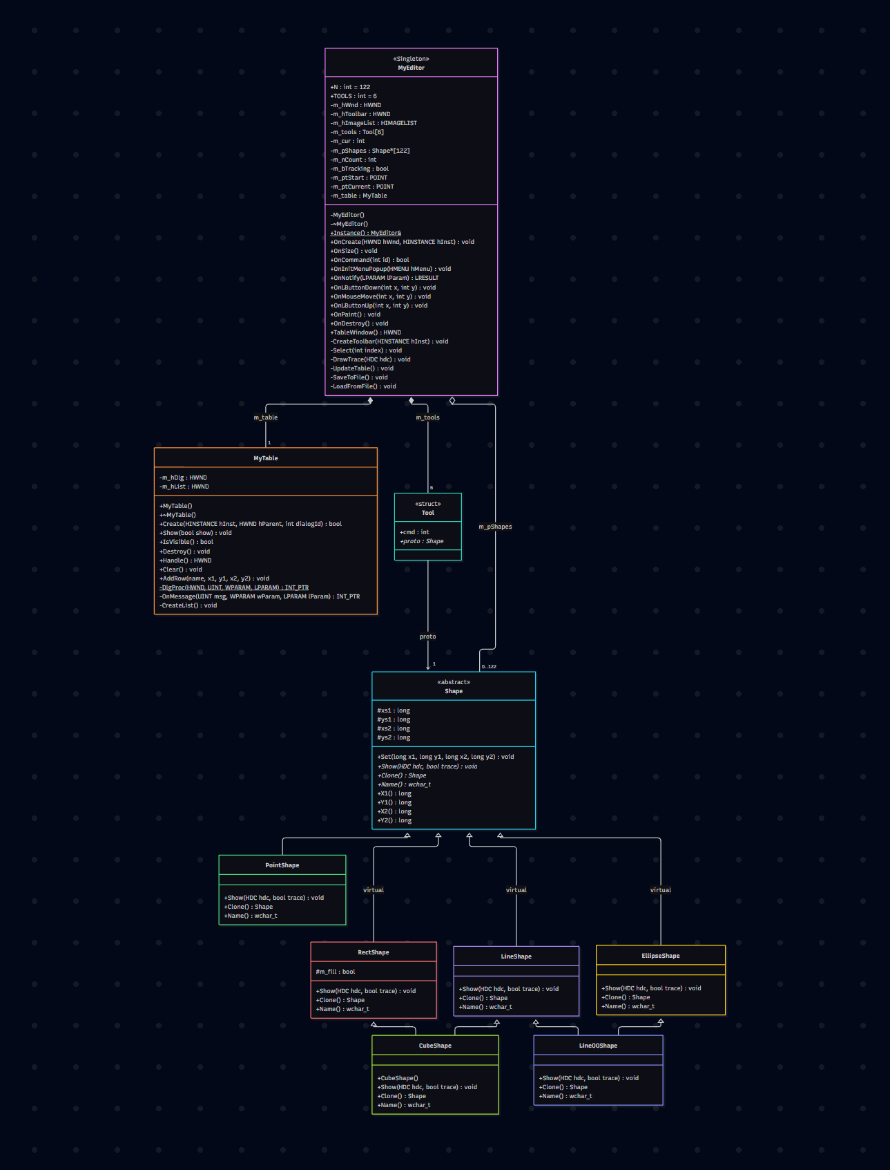

Скріншоти
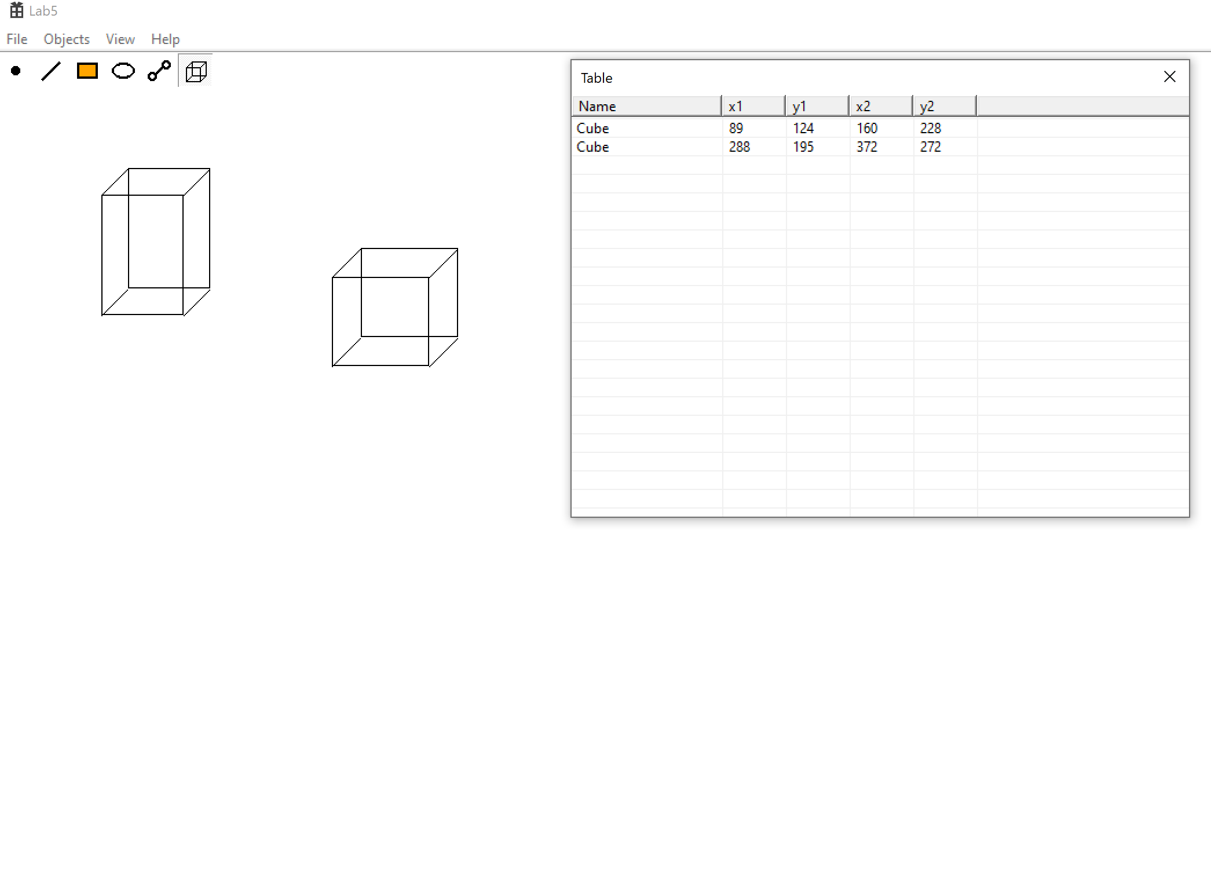

Висновки:
У лабораторній работі я виконав завдання згідно свого варіанту. Та здобув практични навички розробки багатовіконного інтерфейсу користувача для графічного редактора об’єктів

